[Insert your business logo]

[Enter your business name]

Marketing plan
Date: Select a date
[The italicised text in this template has tips to help you complete your marketing plan.
You can remove this text before you finalise your plan.]

Download the latest version of this template from www.business.gov.au/marketingplan

Key details

Registration details
[Find out about business registrations and choosing a business structure.]
Business name
Registered or proposed name.
Date registered | Select date
State registered in | Select state/territory
Business structure | Select structure
Australian business number (ABN)
Australian company number (ACN)
[If a company.]

Contact details
Name
Phone
Mobile
Email
Address

Website and social media details
Description | Web address and details
[Example: Website]
[Example: Facebook]
[Example: Instagram]
[Example: YouTube]
Contents
Key details 2
Registration details 2
Contact details 2
Website and social media details 2
The business 4
Our vision 4
Our mission 4
Products and services 4
SWOT analysis 5
The market 6
Market research 6
The problem 6
Our solution 6
Our target market 6
The competition 7
Goals and actions 8
Marketing goals 8
Marketing strategy 9
Product or service 9
Price 9
Place – our sales and distribution channels 9
People – customer management 10
People – sales and marketing staff 10
Promotion and advertising 11
Measuring results 11
The finances 12
Expected sales 12
Marketing budget 13
Supporting document checklist 14

The business

Our vision
[Consider what you want your business to accomplish. What are your long-term goals? Be passionate, powerful and inspiring.]
Our hopes, dreams and where we aim to go.
[Example: To be the go-to supplier of high quality, sustainable coffee in Australia and reduce environmental impacts by promoting sustainable shopping practices.]

Our mission
[Consider the purpose of your business and define what it does for your customers. What do you do, how do you do it and why do you do it?]
Who we are and why we exist.
[Example: We supply high quality, sustainably produced coffee for all coffee lovers to enjoy while minimising their environmental impact.]

Products and services
What we’re selling.

SWOT analysis
[Take an honest look at your business to identify your business’s strengths and what you could be doing better. Visit our website for more information on doing a SWOT analysis.]
Our business strengths, weaknesses, opportunities and threats.
Strengths  What’s good about our business. | [Example: Premises are in a high-traffic area with good visibility.]
Weaknesses  What’s not so good about our business. | [Example: No online store and high rental costs.]

Opportunities  External factors we could take advantage of. | [Example: The market is growing rapidly.]
Threats  External factors that could cause problems for us. | [Example: A new competitor could target the same market.]

How we’ll address each weakness and threat
[Example: We’ll set up an online store and investigate alternative lower-cost premises with good visibility.]

The market

Market research
[Market research can help you understand the problems customers face and identify opportunities in the market. Attach a copy of your research and findings to this plan.]
Research we’ve done to analyse the market.
[Example: We sent a questionnaire to 30 retail coffee shops, suppliers and other potential customers to assess demand, gaps and issues in the market. We found that most consumers find the large number of coffee brands and blends confusing.]

The problem
[What issues do your potential customers face in the current market? Is there a lack of your service type in a particular suburb? Are the products supplied by other businesses too expensive?]
The problem(s) we will solve for customers.
[Example: There’s an overwhelming choice of coffee blends in the market. It’s hard for customers to know what they’re buying.]

Our solution
How our business solves the problem. This is our unique selling point and how we’ll succeed in the market.
[Example: Intrinsic Coffee sells a small range of high-quality coffee. We don’t use fancy names for our blends so people know what they’re buying.]

Our target market
[Not everyone will want your product or service. Identifying your target market helps focus your marketing efforts and improve your chances of success.
The group of customers that we aim to sell our products or services to.
[Example: Our products are targeted at adults over 30 with a medium-to-high disposable income.]

The competition
The top 3 businesses we’re competing against, what they do well (and not so well), and what we’ll do differently to succeed in the market.
Competitor name | [Example: Sludge International Coffee.]
Strengths | [Example: Low product prices.]
Weaknesses | [Example: Low quality product, unsustainable production.]
What we’ll do differently | [Example: We only sell high quality, sustainably produced beans.]

Goals and actions
[Try to make your goals SMART: specific, measurable, achievable, relevant and time-bound. For example, increase online coffee sales by 10% over the next 12 months.]

Marketing goals
 | [Enter a goal] | [Enter a goal] | [Enter a goal]
How we will achieve this goal | - [Action]  - [Action]  - [Action] | - [Action]  - [Action]  - [Action] | - [Action]  - [Action]  - [Action]
Due date | Select date | Select date | Select date
Who’s responsible

Marketing strategy
[Read our article about the 5 Ps of marketing – product, price, place, people and promotion.]

Product or service
Where our products or services fit in the market. What makes them different from our competitors’ products or services.
Product/service | Description | Unique selling point
[Example: EcoBeans] | [Example: EcoBeans are environmentally friendly coffee beans for our environmentally conscious customers.] | [Example: These beans are sourced from a sustainable supplier and packaged in eco-friendly materials. They let our customers have a positive impact on the environment.]

Price
[Explain your pricing strategy and why you chose it. Does the price cover all costs such as staff, production and operations? Have you added a profit margin? What price will your target market accept? Do your prices account for any seasonal variations in costs?]
How we set the prices for our products or services.
[Example: We sell our coffee beans at the cost of production and distribution plus a mark-up of 50%. This ensures we remain competitive and make a profit.]

Place – our sales and distribution channels
[How will you deliver your product or service to customers? For example, wholesale, a shopfront, a website or a market stall. Think about your target audience when you choose distribution channels.]
Channel | Used for | Details
[Example: website] | [Product or service] | [Example: Beans Online, 20% of sales]

People – customer management
[How will you maintain good relationships with your customers and keep them coming back? Check our customers topic for more information.]
[Example: We’ll create and maintain customer service standards. We’ll offer discounts to regular customers. We’ll let customers know about special offers and new products through an opt-in newsletter.]

People – sales and marketing staff
[List your existing or required sales and marketing staff.]
Role | Name  [If role is filled.] | Responsibilities
[Example: Sales manager] |  | [Example: Develop marketing plan, monitor sales and set sales targets.]

Promotion and advertising
[Choose channels that suit your target market. Learn about choosing the best channels to communicate with your customers.]
The channels we’ll use to promote and advertise to our target customers.
Activity | Channel | Details | Estimated cost | Target date
[Example: Pre-launch promotion.] | [Example: social media.] | [Example: We’ll use regular Facebook posts to promote the product with discounts for our first 20 customers.] | $ | Select date
 |  |  | $ | Select date
 |  |  | $ | Select date
 |  |  | $ | Select date

Measuring results
[Describe how you’ll regularly review the impact of your planned marketing activities. What were the results for the marketing period? What were your sales figures? How many new and repeat customers did you receive? How many visitors to your website?]
Marketing activity | Date of review | How we’ll measure the impact | Results
[Example: Pre-launch promotion.] | Select date | [Examples: social media hits, number of online orders] | [Examples: new customers, increased demand, increased profit]
 | Select date
 | Select date
 | Select date

The finances
[Use your financial statements and forecasts to complete this section. Our financial templates can help you track your finances.]

Expected sales
[Describe your expected sales figures, including any seasonal influences.]
Our expected sales for the next year.
[Example: Our expected sales for the 20XX-20XX financial year are $XXXX.]

Marketing budget
[You can base your budget on the example below, use your own budget or ask your accountant for help. Figures include GST.]
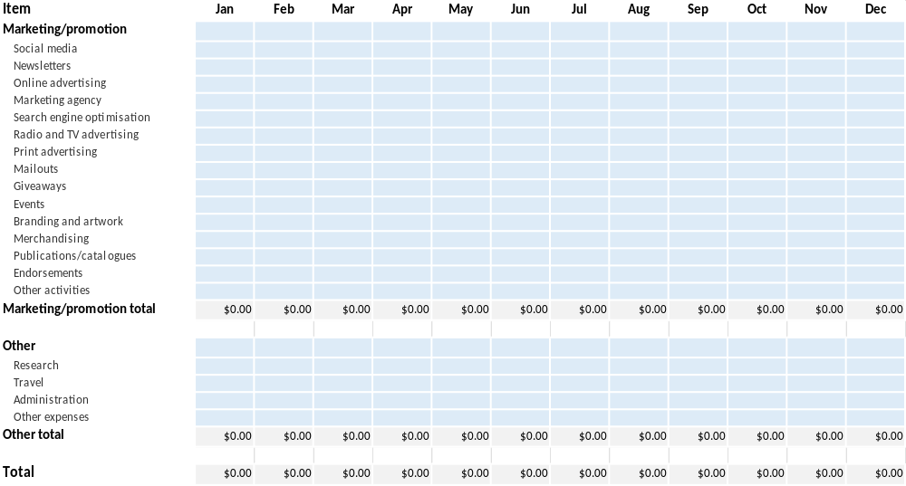

Supporting document checklist
Attached documents (where relevant):
☐ Balance sheet forecast (including assumptions)
☐ Cash flow statement forecast (including any assumptions)
☐ Market research
☐ Profit and loss forecast sheets (including any assumptions)
☐ Staff resumes

